SPH3U0 **Properties of Sound-Student Note Sheet Date:___________**

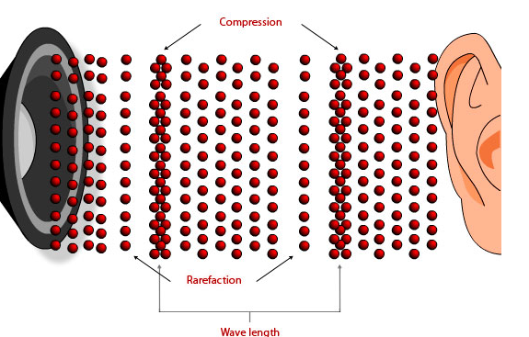**Type of Wave:** •

•

**Sound Frequency**

|  |  |  |
| --- | --- | --- |
| **__________________**  **__________________** | **Audible Range**  **___________________** | **__________________**  **____________________** |

**Sound Intensity**

• Sound intensity is a measure of the energy per unit area that passes a point per second Units: W/m2

• ___________________________________________________________________________________________

**The Decibel Scale**

•A more convenient scale is the logarithmic decibel (dB) scale-named after Alexander Graham Bell!

**Recall: Exponents and logarithms:**

**103=1000 log101000 = 3**

• _________________________________________________________________________

**See page 326 Sound Intensities**

|  |  |  |  |  |
| --- | --- | --- | --- | --- |
| **Source of Sound** | **Intensity W/m2**  **(W/m2) W/m2)** | **Intensity pW/m2**  **(pW=10-12 W)** | **Intensity Level (B)** | **Intensity Level (dB)** |
| **Threshold of human hearing** |  |  |  |  |
| **Rustling leaves** |  |  |  |  |
| **Whisper** |  |  |  |  |
|  |  |  |  |  |
|  |  |  |  |  |
|  |  |  |  |  |
|  |  |  |  |  |
|  |  |  |  |  |
|  |  |  |  |  |
|  |  |  |  |  |
|  |  |  |  |  |
|  |  |  |  |  |
|  |  |  |  |  |
|  |  |  |  |  |
|  |  |  |  |  |

**Intensity Changes:**

Each 10 dB step on the decibel scale corresponds to a multiplication factor of 10!

Example: How much more intense is a 80 dB sound than a 50 dB sound?

Answer:

Speed of Sound

•

•

• Examples: vair (0 ° C)=332 m/s vwater (25 ° C)= 1493 m/s Vsteel =5790 m/s

Speed of Sound in Air

**Speed of sound in air depends on temperature:**

T is ____________________________

**Examples: What is the speed of sound in air if the temperature is:**

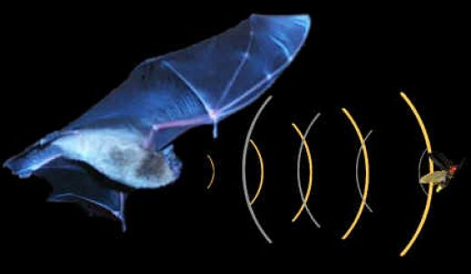a) 28 °C b) -15 °C

**Echolocation**

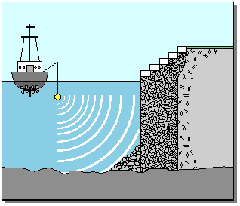•

•

•

When calculating the echo time remember that the sound has travelled twice the distance!



Example: A student stands near the base of a cliff and claps her hands. She hears the echo

in 3.0 s. Find the distance to the cliff if the speed of sound in air was 346.8 m/s that day.